BPMN 2.0 cheat sheet

Essential elements and notation guide

Step 3: Identify process challenges and root causes

Purpose: This cheat sheet summarizes the most commonly used symbols and rules in BPMN 2.0 to help you build clear and effective process models in SAP Signavio or any BPMN-compliant tool.

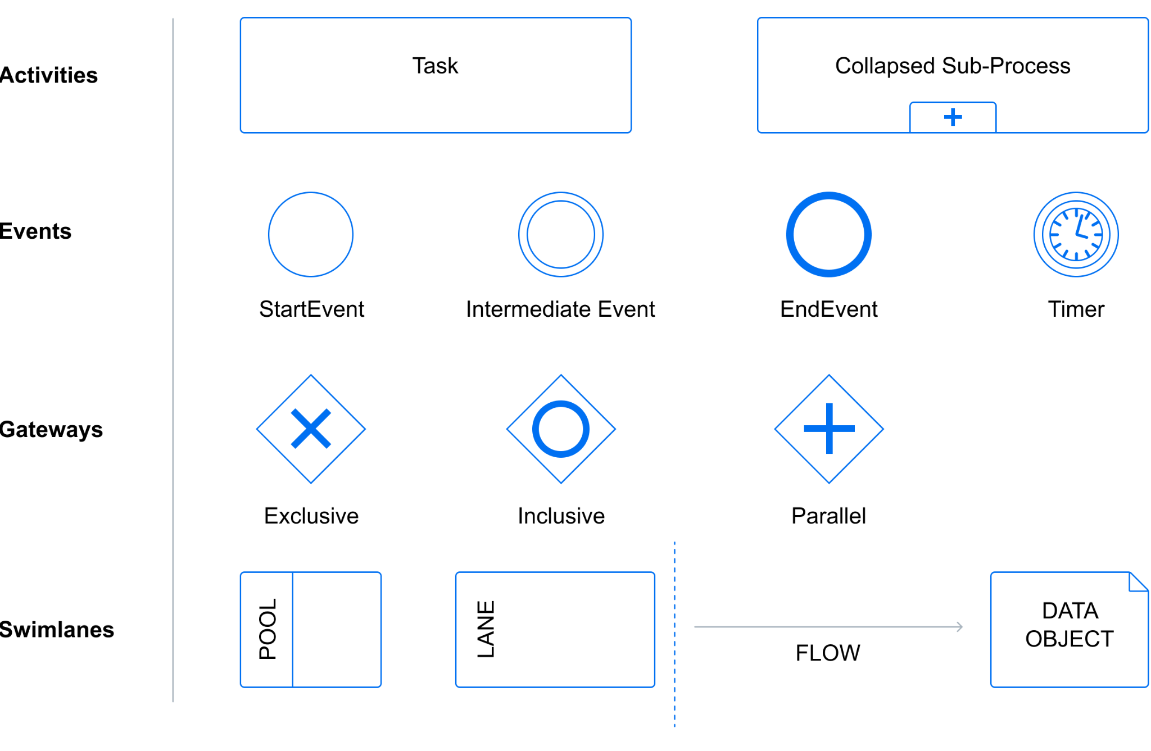

Image: SAPC3M4A04_img01
Alt text: Diagram showing common BPMN symbols for Activities, Events, Gateways, and Swimlanes.

Basic Elements
Start Event
- Symbol: Circle with a thin border
- Meaning: Indicates where the process begins
- Example: Process initiated by a customer order
End Event
- Symbol: Circle with a thick border
- Meaning: Marks the end of the process
- Example: Order fulfilled and closed
Task/Activity
- Symbol: Rounded rectangle
- Meaning: Represents a single unit of work (manual or automated)
- Types:
  - User Task (manual)
  - Script Task (automated)
  - Service Task (system-invoked)
Gateway
- Symbol: Diamond shape
- Meaning: Decision points or process divergence/convergence
- Types:
  - Exclusive Gateway (XOR): One path only
  - Parallel Gateway (AND): All paths proceed simultaneously
  - Inclusive Gateway (OR): One or more paths may be taken
Sequence Flow
- Symbol: Solid arrow
- Meaning: Shows the order of process steps
Message Flow
- Symbol: Dashed arrow with open circle at start
- Meaning: Communication between different participants (e.g., between pools)
Association
- Symbol: Dashed line
- Meaning: Links text annotations or data to activities/events

Swimlanes and Pools
Lane
- Meaning: Represents a specific role, system, or department involved in the process
- Used to organize tasks within a single pool
Pool
- Meaning: Represents an independent participant (e.g., company or external entity)
- Used to model collaboration between participants

Events (Optional Extensions)
Intermediate Event
- Symbol: Circle with double border
- Meaning: Occurs between start and end; can interrupt or wait for a signal/message
Timer Event
- Symbol: Clock inside a circle
- Use: Waiting periods, deadlines
Error Event
- Symbol: Lightning bolt inside a circle
- Use: Exception handling in a process

Modeling Tips

- Always begin with a clear Start Event and end with an End Event
- Keep flow from left to right for clarity
- Use gateways to show decisions; avoid branching without them
- Group related activities in Lanes to clarify roles
- Use annotations to explain complex steps when needed
- Use consistent labeling (verbs + nouns) for tasks, e.g., "Approve Invoice"

Best Practices

- Model only to the level of detail necessary
- Avoid crossing sequence flows
- Test your process logic: Can you trace a path from start to end clearly?
- Validate your model with SMEs before finalizing
Use this reference to support your process mapping in exercises and real-world modeling using SAP Signavio or similar BPMN tools.

